Axiom Requisition Copy Service
2869 Jolly Rd, Okemos, Michigan 48864
517.886.5099 – 877.886.5090 toll free – 517.886.4116 facsimile – records@axiomcopy.com

REQUEST FOR RECORDS - ORDER NUMBER 01-27782-005

TO THE CUSTODIAN OF RECORDS Date Sent: November 8, 2026
Macomb Family Services
Dept. Medical Records
36975 Utica Road Suite 104
Clinton Twp., MI 48036
Please find enclosed a request for records of:
Sharon Reynolds
DOB 09/23/1969 SSN XXX-XX-7150
We are requesting the following:

FROM 09/23/1969 TO PRESENT: ANY and ALL records, including but not limited to any and all documentation or other records generated by any outside source pertaining to Sharon Reynolds SSN: XXX-XX-7150, DOB: 09/23/1969.

INSTRUCTIONS
- FORWARD INVOICE WITH RECORDS – If fee is greater than $50.00 Pre-approval is required.
- PLEASE DO NOT STAPLE DOCUMENTS.
- Mail, email or fax the records to: Axiom Requisition Copy Service (as agent of Frederick Ecclestone, McLeod & Associates), 2869 Jolly Rd, Okemos, MI 48864 – Phone: 517.886.5099 – Fax: (517) 886-4116 – Email: records@axiomcopy.com.

SIGN AND RETURN THIS FORM WITH THE REQUESTED RECORDS
__________________________________________________________
CERTIFICATION OF RECORD SUBMISSION
I certify in response to the request issued to me, that I have submitted a true and complete copy of all requested documents in my control or possession relating to the above person; and that (A) The record was made at or near the time of the occurrence of the matters set forth by, or from information transmitted by, a person with knowledge of those matters; (B) The record was kept in the course of the regularly conducted business activity; and (C) It was the regular practice of the business activity to make the record.

_____________________________________________ _____________________
Signature of the custodian of records Date

If you are sending only part of the documents requested above and some are not in your possession, please check the appropriate boxes below:
- No Medical Records ◻ No X-Ray Films ◻ No Photographs ◻ No Billing Records
If you do not have any of the records requested, please contact our office for an affidavit of no records or send us a letter on your letterhead stating you do not have any of the records requested.

ORDER NUMBER 01-27782-005

STATE OF MICHIGAN  ST CLAIR CIRCUIT  JUDICIAL DISTRICT  JUDICIAL CIRCUIT  COUNTY PROBATE | SUBPOENA  Order to Appear and/or Produce | CASE NO.  2012-000987-NO
Court address , , ,
Plaintiff(s)/Petitioner(s)  People of the State of Michigan  X SHARON REYNOLDS, INDIVIDUALLY AND ROBERT REYNOLDS,  INDIVIDUALLY ADN AS NEXT FRIEND OF BRIANNA  REYNOLDS | v | Defendant(s)/Respondent(s)  PORT HURON AREA SCHOOL DISTRICT AND  THUMB AREA FOOTBALL LEAGUE
X Civil Criminal |  | Charge
Probate In the matter of ____________________________________________________________________________________________
In the Name of the People of the State of Michigan. TO: Macomb Family Services
36975 Utica Road Suite 104
Clinton Twp., MI 48036
YOU ARE ORDERED:
X 1. To send to the place at the time stated: You may be required to appear from time to time and day to day until you are excused.
PLEASE PROVIDE DOCUMENTS/MATERIALS TO: Axiom Requisition Copy Service, 2869 Jolly Rd, Okemos, Michigan 48917
Day | Date | Time
«DayName» | «BigDate» | 9:00 a.m.

2. Testify at trial / examination / hearing.
X 3. Produce / permit inspection or copying of the following items:
FROM 09/23/1969 TO PRESENT: ANY and ALL records, including but not limited to any and all documentation or other records generated by any outside source pertaining to Sharon Reynolds SSN: XXX-XX-7150, DOB: 09/23/1969.

4. Testify as to assets, and bring with you the items listed in line 3 above.
5. Testify at deposition.
6. MCL 600.6104(2), 600.6116, or 600.6119 prohibition against transferring or disposing of property is attached.
X 7. Other: RECORDS SHOULD BE MAILED, FAXED OR EMAILED TO Axiom Requisition Copy Service FOR THE ATTORNEY.
X 8.
Person requesting subpoena  Frederick Ecclestone, Esquire |  | Telephone no.  517.886.5099
Address
c/o Axiom Requisition Copy Service, 2869 Jolly Rd
City  Okemos | State  Michigan |  | Zip  48864

NOTE: If requesting a debtor’s examination under MCI.600.6110 or an injunction under item 6 this subpoena
must be issued by a judge. For a debtor examination, the affidavit of debtor examination on the other side of this form must also be completed. Debtor’s assets can also be discovered through MCR 2.305 without the need for an affidavit of debtor examination or issuance of this subpoena by a judge.

FAILURE TO OBEY THE COMMANDS OF THE SUBPOENA OR APPEAR AT THE STATED
TIME AND PLACE MAY SUBJECT YOU TO PENALTY FOR CONTEMPT OF COURT.

Frederick Ecclestone TWV
 |  |  |  | P26313 |  | Court use only
Date |  | Judge/Clerk/Attorney |  | Bar No. |  | □ Served □ Not served

Order No. 01-27782-005
MCL 600.1455, 600.1701, 600.6110, 600.6119, MCR 2.506
MC 11 (6/04) SUBPOENA, Order to Appear and/or Produce

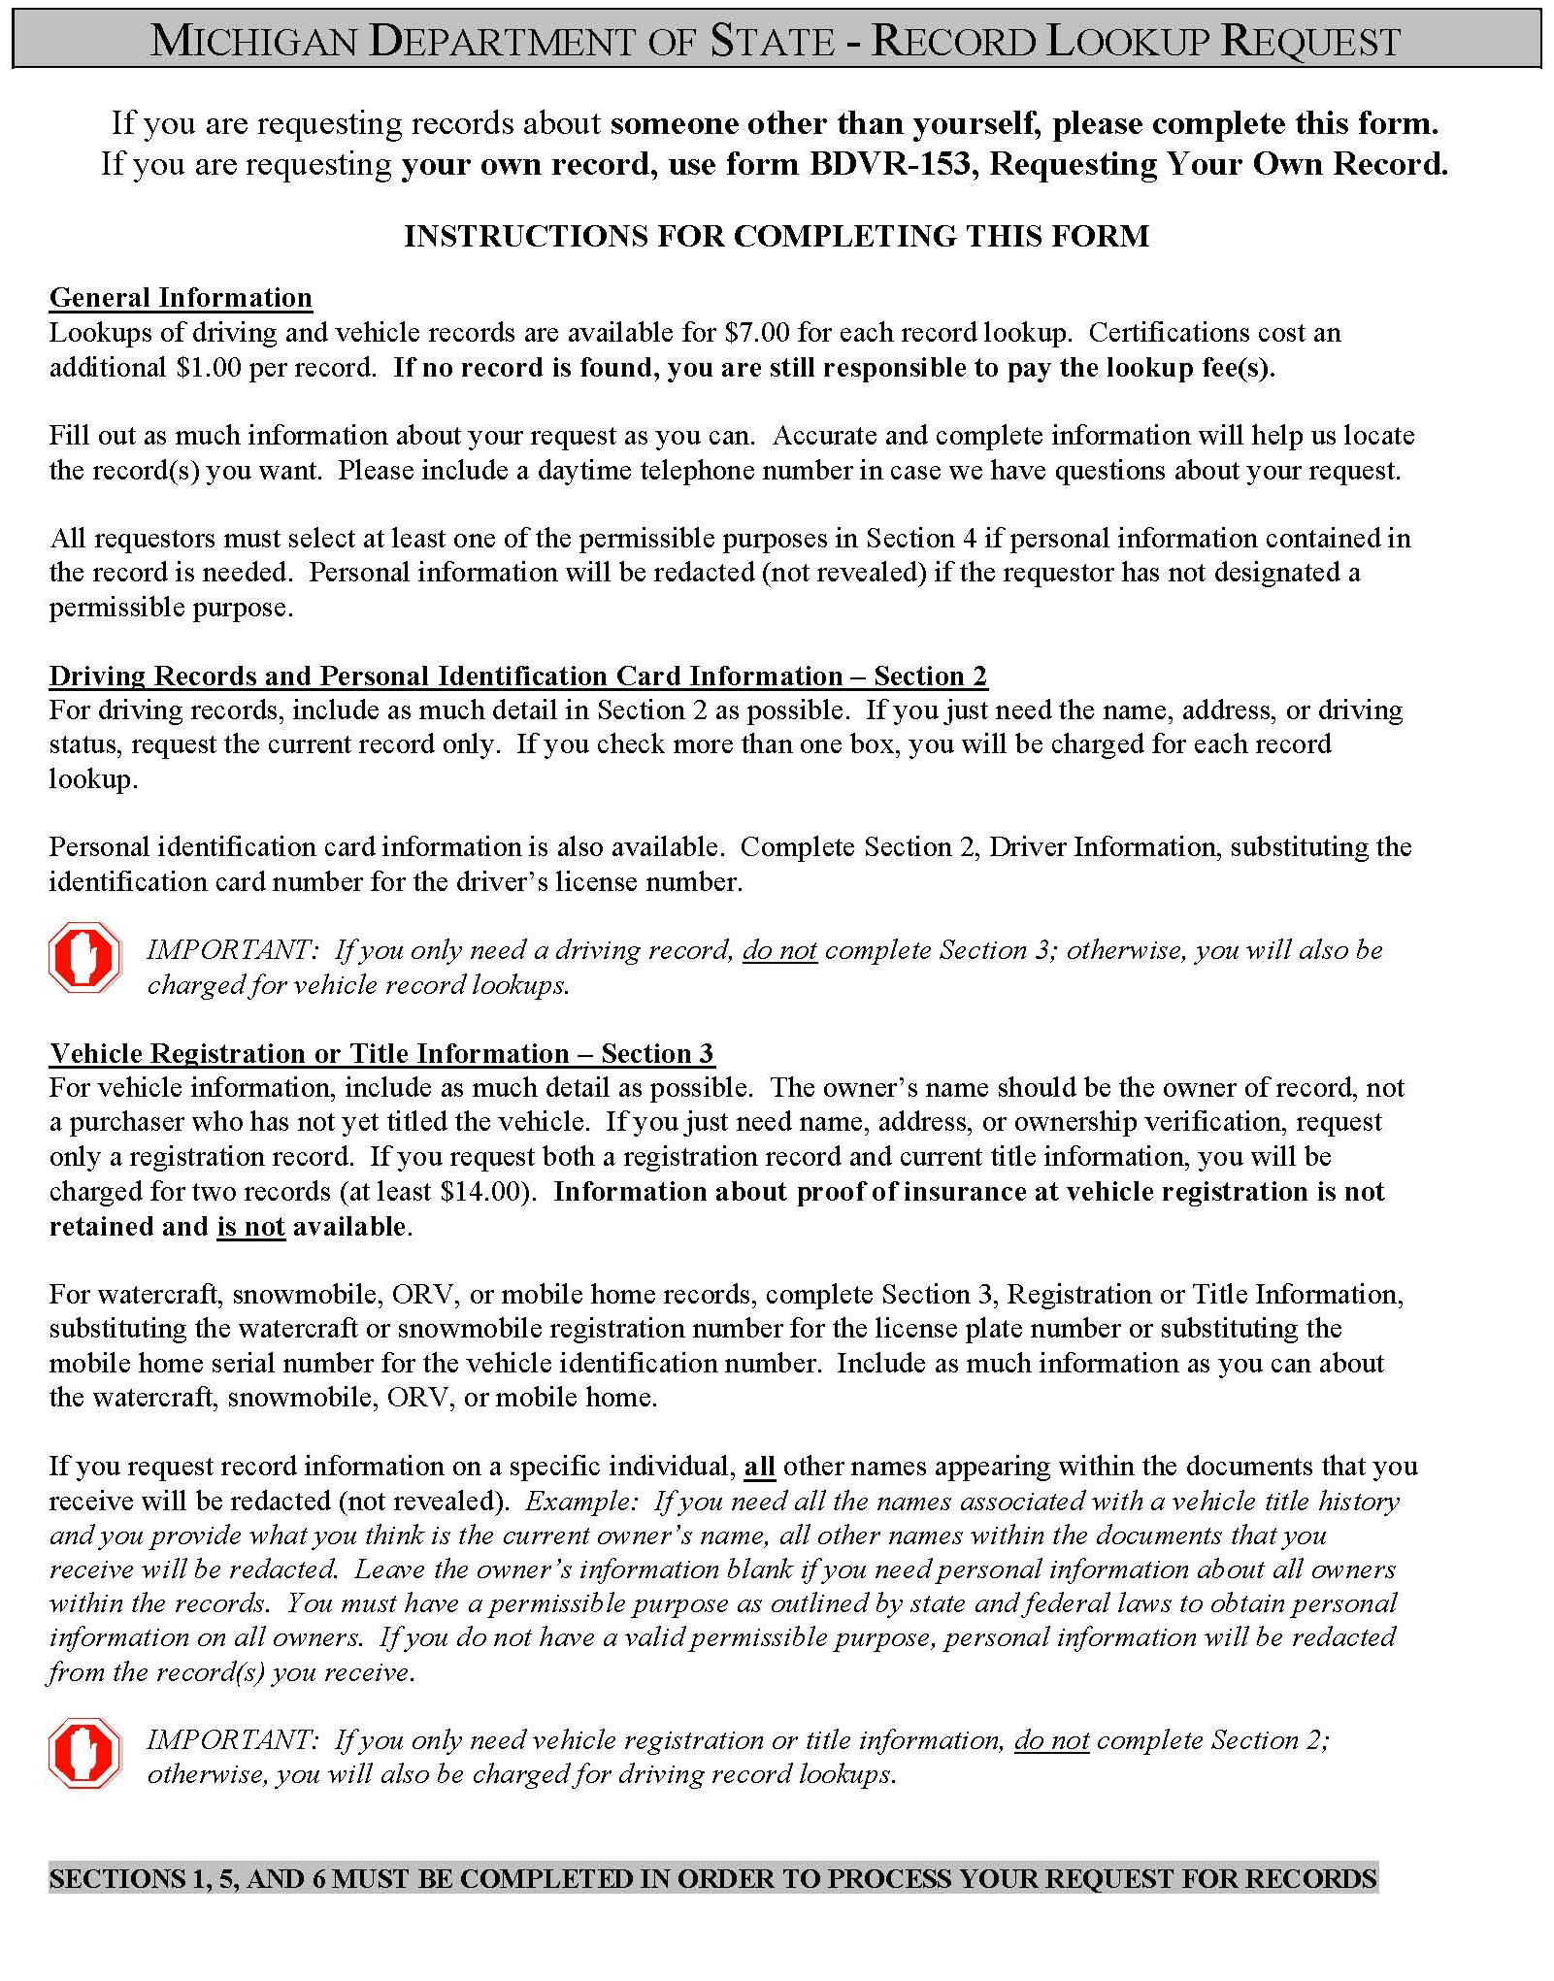

Michigan Department of State – Record Lookup Request
If you are requesting records about someone other than yourself, please complete this form.
If you are requesting your own record, use form BDVR-153, Requesting Your Own Record.
Section 1. Requestor (Please print or type all information.)
Requestor Name (Individual or Company)  Axiom Requisition Copy Service |  |  |  |  |  |  |  |  |  |  |  |  |  |  |  |  |  |  |  | Agent’s Name and Title (if company)  Leah D. Boroski, Account Executive
Mailing Address  2869 Jolly Rd |  |  |  |  |  |  |  |  |  |  |  |  |  |  |  |  |  |  |  |  |  |  |  |  |  |  |  |  |  |  |  |  |  |  |  |  |  |  | File or Claim Number
City  Okemos |  |  |  |  |  |  |  |  |  |  |  |  | State  Michigan |  |  |  |  |  | Zip Code  48864 |  |  |  |  |  |  |  |  |  |  |  |  |  |  |  |  |  |  |  | Daytime Telephone Number  (877) 886-5090
Section 2. Driver Information (If you only want a driving record, leave Section 3 blank.)
☑ Driving Record for:  (Shows last reported address) |  |  |  |  |  |  |  | - Employment or Insurance  - Court  ☑ Other: Legal Matter
☑ Current Application  ◻ Application History*  ◻ Address History* |  |  |  |  |  |  |  | } |  | For partial histories, please complete: from _____/_____/_____ to _____/_____/_____
◻ Other Driving-Related Record(s) _________________________________________________________Date_____/_____/_____
(Hearing, Offense, License Status, etc.)
Driver’s Full Name (First, Middle, Last) |  |  |  |  |  |  |  |  |  |  |  |  |  | Driver’s License Number  09/23/1969 |  |  |  |  |  |  |  |  |  |  |  |  |  |  |  |  |  |  |  |  |  |  |  |  |  |  |  |  | Date of Birth Date
Sharon Reynolds
Driver’s Full Name (First, Middle, Last) |  |  |  |  |  |  |  |  |  |  |  |  |  | Driver’s License Number |  |  |  |  |  |  |  |  |  |  |  |  |  |  |  |  |  |  |  |  |  |  |  |  |  |  |  |  | Birth Date
Section 3. Vehicle Registration or Title Information (Insurance information is not retained and is not available.)
Note: $7.00 is charged for each record lookup. Complete histories can be expensive.
(If you only need a vehicle record, leave Section 2 blank; otherwise, you will be charged for multiple records.)
License Plate or  Registration Number |  |  |  |  |  |  | Vehicle  Year |  |  |  | Make and Model |  |  |  |  |  |  | Vehicle or Hull Identification Number
Check boxes that apply:
◻ Current Vehicle Owner and Lienholder Information
◻ Registration Information as of _____/_____/_____
◻ Copy of Current Title Application and Related Forms
◻ Complete Title History*
☑ Complete Registration History*
- Partial Title History*  - Partial Registration History* |  |  |  |  |  |  |  |  |  |  | } | For partial histories, please complete: from _____/_____/_____ to _____/_____/_____
Check box if you want: |  |  |  |  |  |  | - All motor vehicles registered or titled to this owner.**  - All other registered or titled assets for the owner indicated.**
Vehicle Owner(s) Name
Sharon Reynolds
Vehicle Owner(s) Address
43496 Hillsboro
City  Clinton Township |  |  |  |  |  |  |  |  |  |  |  |  |  |  |  |  |  | State  Michigan |  |  |  |  |  |  |  |  |  |  |  |  |  |  |  |  |  |  |  |  |  |  |  | Zip Code
* Buying a complete or partial title, application, and/or address history can be very expensive. The lookup fee is charged for each address or title change or correction.  ** When requesting records for all motor vehicles or all assets registered and/or titled thru the Michigan Department of State for individuals and/or companies, precise information is required. Information retrieved is based upon an exact name and address match. The individual’s name and address, as provided by the record requestor, must match the name and address on the record(s) held by the Michigan Department of State. |  |  |  |  |  |  |  |  |  |  |  |  |  |  |  |  |  |  |  |  |  |  |  |  |  |  |  |  |  |  |  | For Office Use Only
 |  |  |  |  |  |  |  |  |  |  |  |  |  |  |  |  |  |  |  |  |  |  |  |  |  |  |  |  |  |  |  | BDVR-154-WEB (02/08)
SECTIONS 1,5, AND 6 MUST BE COMPLETED IN ORDER TO PROCESS YOUR REQUEST FOR RECORDS

Order No. 01-27782 - 005
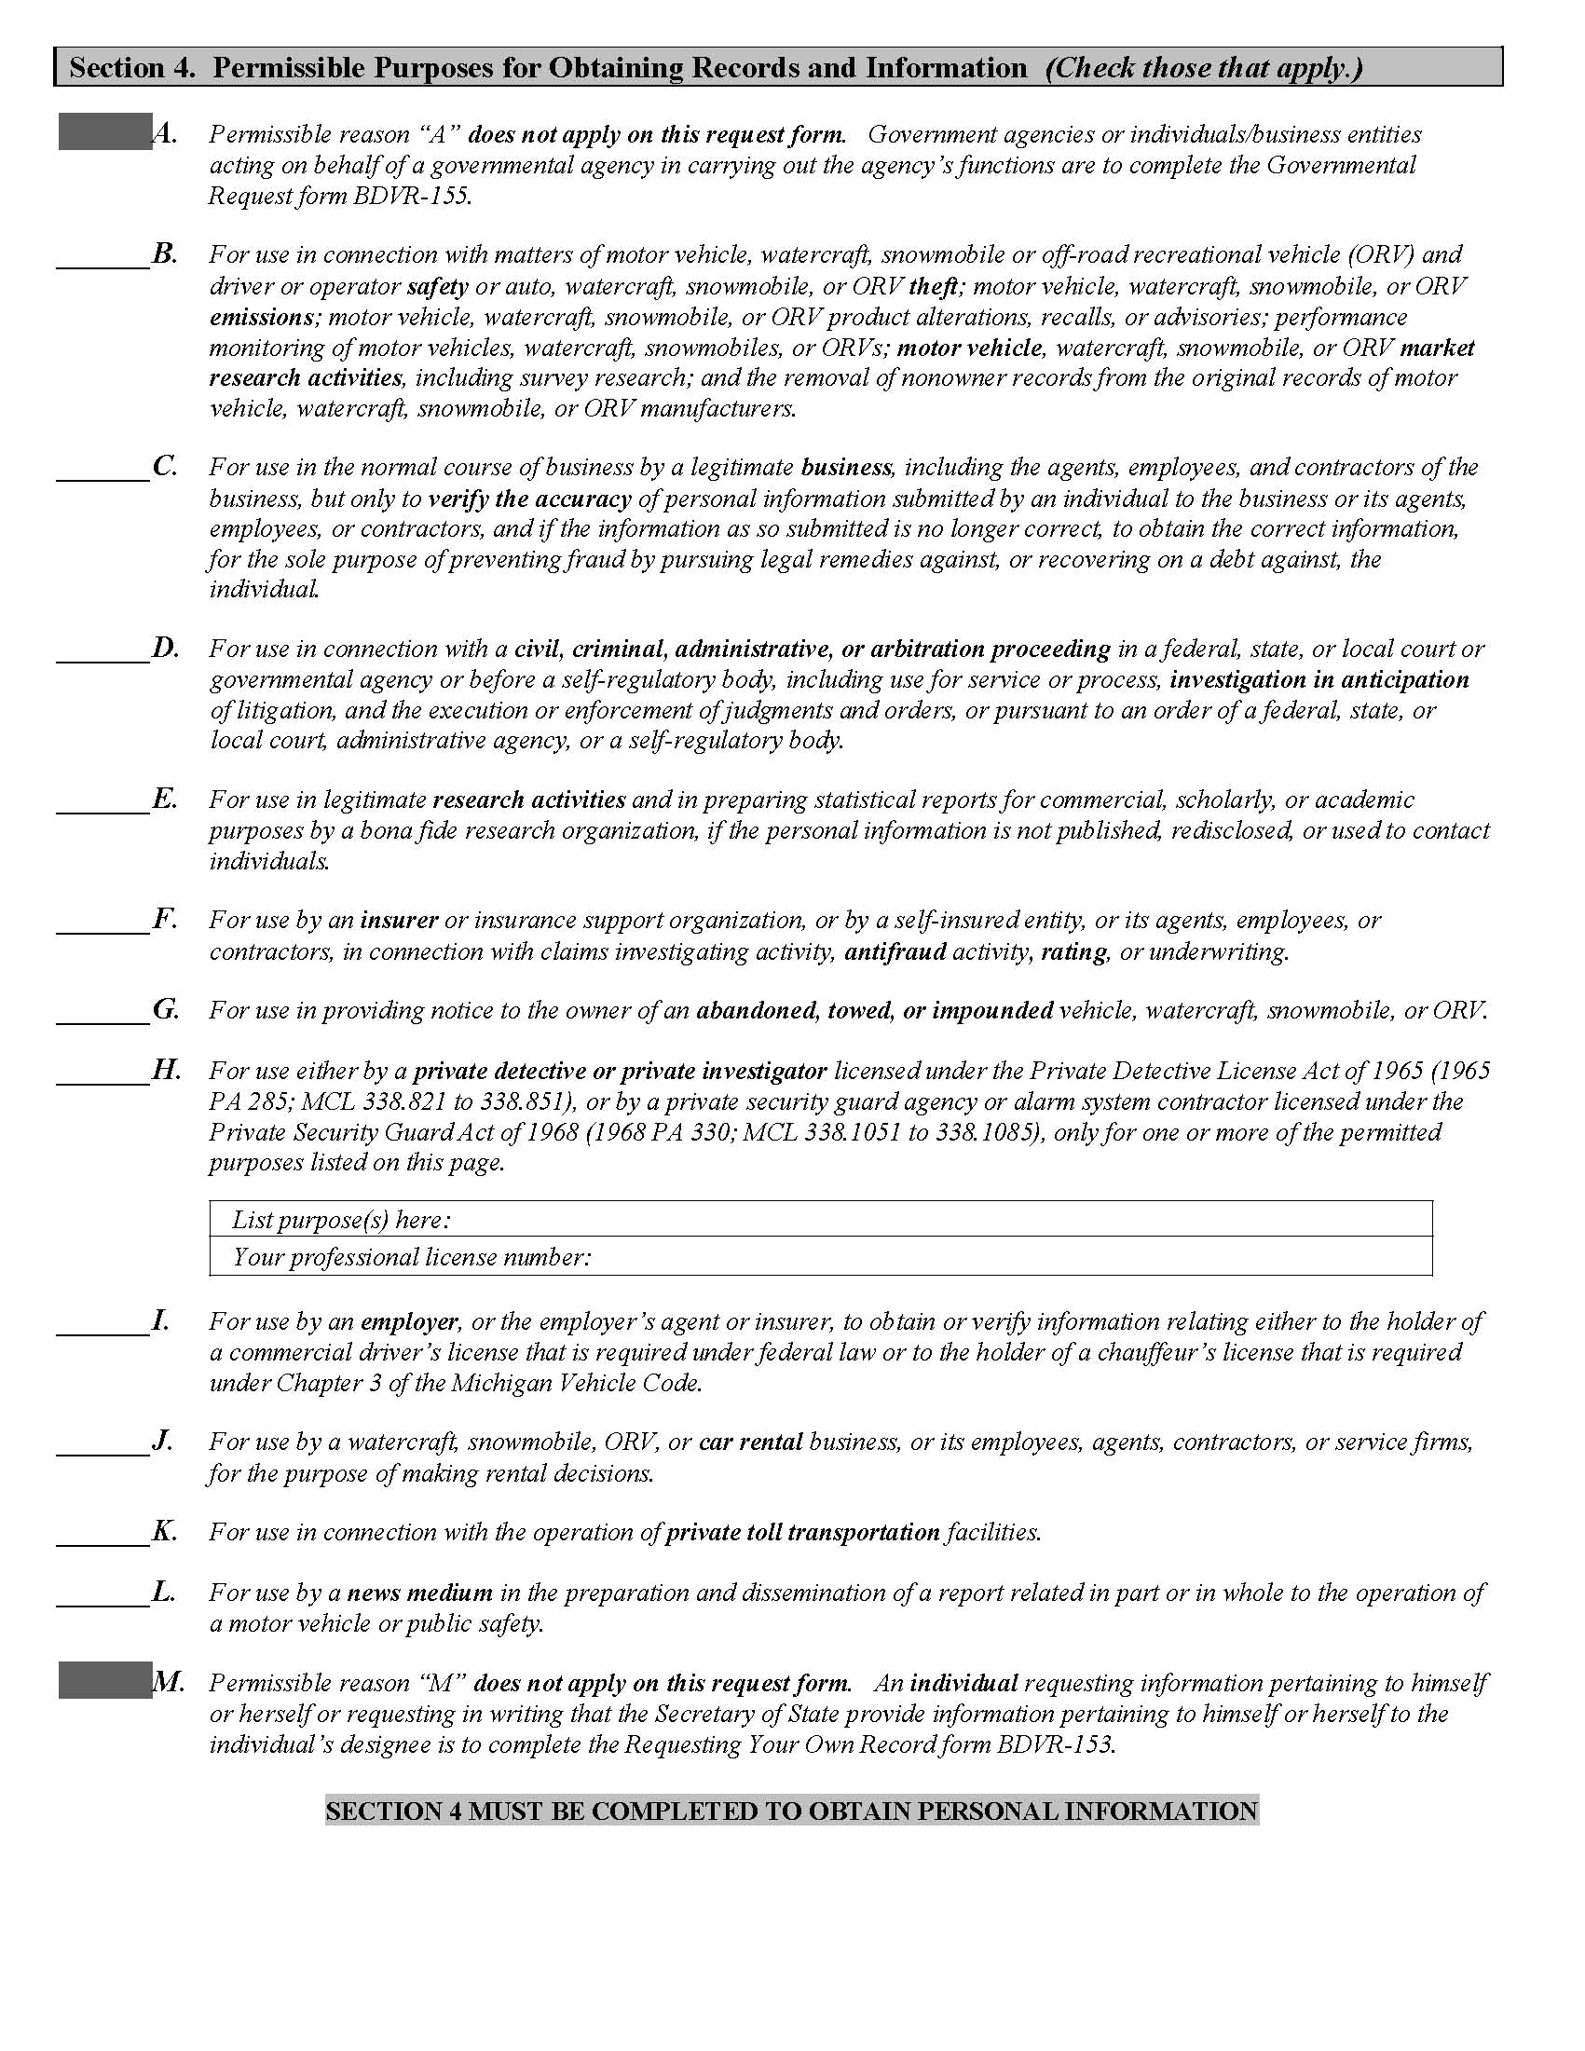
X
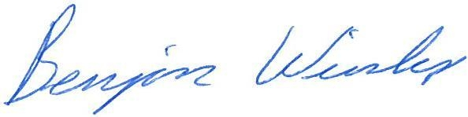
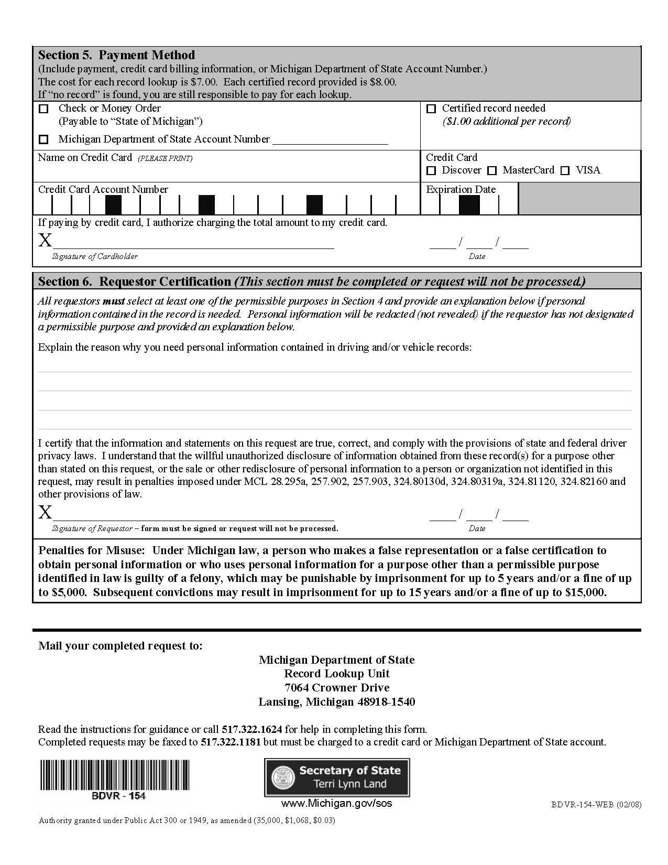
Legal Action of Reynolds v. Port Huron Area School District et al

